Connected Counterparty
Senzing and Neo4j:
For our connected counterparty risk platform senzing fits mainly at the entity resolution layer, before Neo4j builds the relationship graph. Neo4j is our relationship and graph database. It tells us how counterparties are connected. Sezing solves a different problem – entity resolution. It identifies when records from CRM, KYC, trading Watchlists, etc. actually, refer to the same real world counterparty. We can use senzing first to create trusted entities and then use Neo4j to build the connected counterparty risk graph.
1. What problem does Senzing solve?
Suppose systems contain:
System A:
"Alpha Urban Holdings Inc"
Address: 10 Park Street
Country: US

System B:
"Alpha Urban Holdings"
Address: 10 Park St.
Country: USA

System C:
"Alpha Urban Hldgs Inc."
Address: 10 Park Street
Country: US

A normal database may treat these as three different companies.
Senzing analyzes attributes such as names, addresses, identifiers and other features and determines that these records are likely to represent the same real-world entity. Senzing's entity specification is specifically designed to map source records into its resolution engine
So,
3 source records
↓
Senzing
↓
Real-world Entity
"Alpha Urban Holdings Inc"
↓
Neo4j
↓
Relationship / Risk Graph

2. Where would we use the Senzing API?
I'd put it between the source systems and Neo4j.
SOURCE SYSTEMS
┌──────────┬──────────┬──────────┐
↓ ↓ ↓
CRM Trading KYC/AML
↓ ↓ ↓
└────────────────────┘
↓
Data Transformation
↓
SENZING API
↓
Entity Resolution
↓
┌────────────┴────────────┐
↓ ↓
Canonical Entity Match Evidence
↓ ↓
└────────────┬────────────┘
↓
NEO4J
↓
Relationship Graph
↓
Risk Calculation / UI

3. Example using your Alpha Urban Holdings (Counterparties Tab)
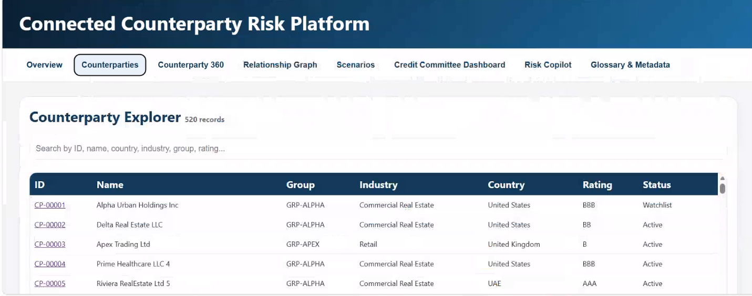
The application currently shows:
CP-00001 — Alpha Urban Holdings Inc
Imagine the bank has these records:
{
"DATA_SOURCE": "CRM",
"RECORD_ID": "CRM-1001",
"NAME_ORG": "Alpha Urban Holdings Inc",
"ADDR_LINE1": "10 Park Street",
"COUNTRY": "US"
}
Another System:
{
"DATA_SOURCE": "TRADING",
"RECORD_ID": "TRD-7832",
"NAME_ORG": "Alpha Urban Hldgs",
"ADDR_LINE1": "10 Park St",
"COUNTRY": "USA"
}
And KYC:
{
"DATA_SOURCE": "KYC",
"RECORD_ID": "KYC-4451",
"NAME_ORG": "Alpha Urban Holdings, Inc.",
"ADDR_LINE1": "10 Park Street",
"COUNTRY": "United States"
}
Send these records through Senzing.
Senzing can resolve them to the same underlying entity.
Conceptually:
CRM-1001 ─────┐
│
TRD-7832 ─────┼──→ Senzing Entity 12345
│
KYC-4451 ─────┘
"Why were these records resolved to the same entity?"

For example:
Name similarity Strong
Address match Strong
Registration ID Exact
Country Match

Senzing provides entity retrieval and relationship information, and its output can include records composing an entity and related entities.

4. Relationship Graph Tab— this is where Senzing + Neo4j become powerful
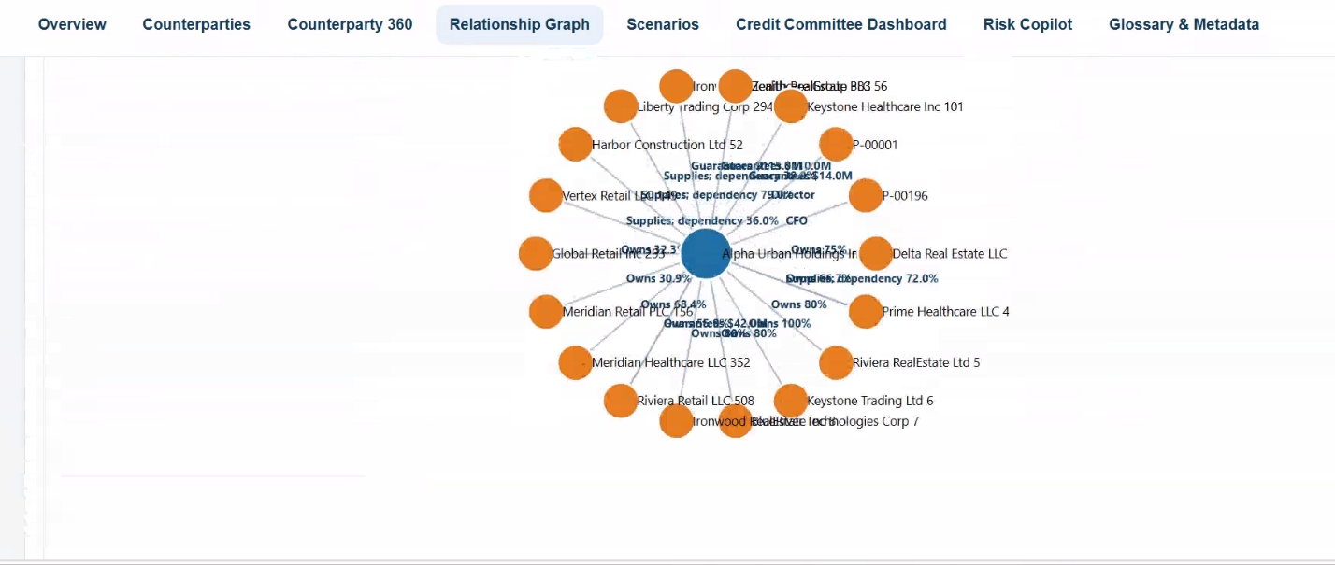

Alpha Urban Holdings
│
├── Delta Real Estate
├── Prime Healthcare
├── Keystone Trading
├── Riviera Real Estate
└── ...
But before Neo4j creates this graph, we need to know:
Are Alpha, Delta, Prime, etc. actually unique entities?
That's where Senzing comes first.
Pipeline:
Raw Records
↓
Senzing
↓
Resolved Entities
↓
Neo4j
↓
Relationships
↓
Level 1 / Level 2 Graph
Senzing can also provide related entities and relationship/matching information that can be consumed downstream.
Example:
Suppose we have:
Alpha Urban Holdings Inc
Alpha Urban Holdings
Alpha Urban Hldgs Inc
Senzing:
ENTITY 12345
│
┌─────────┼─────────┐
↓ ↓ ↓
CRM KYC Trading
Neo4j then stores:
(:Entity {senzingId: 12345})
│
│ OWNS
↓
(:Entity {senzingId: 67890})

So: Senzing identifies the node. Neo4j connects the node.
____________________________________________________________________

5. Scenarios tab

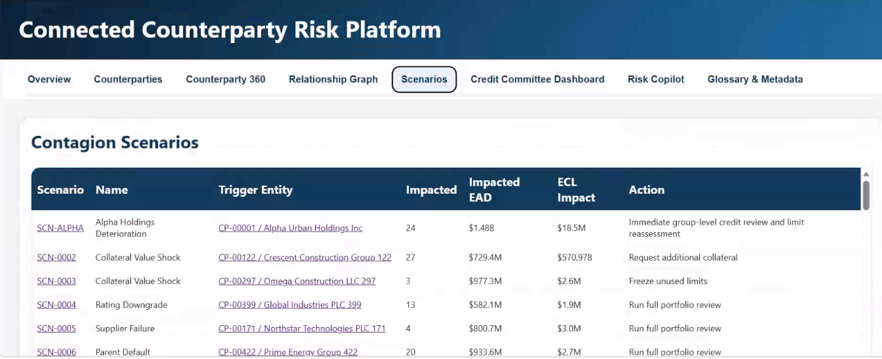
scenario screenshot shows things like:
Alpha Holdings Deterioration
24 impacted entities
$1.48B EAD impact
$18.5M ECL
Senzing can help answer:
Which records/entities are impacted?
For example:
Scenario Trigger
↓
Alpha Urban Holdings
↓
Senzing Entity 12345
↓
Neo4j
↓
Connected entities
↓
Risk engine
↓
EAD / ECL / RWA
So, the responsibility becomes:
Senzing → WHO?
Neo4j → CONNECTED TO WHOM?
Risk Engine → HOW MUCH RISK?
___________________________________
6. Credit Committee Dashboard
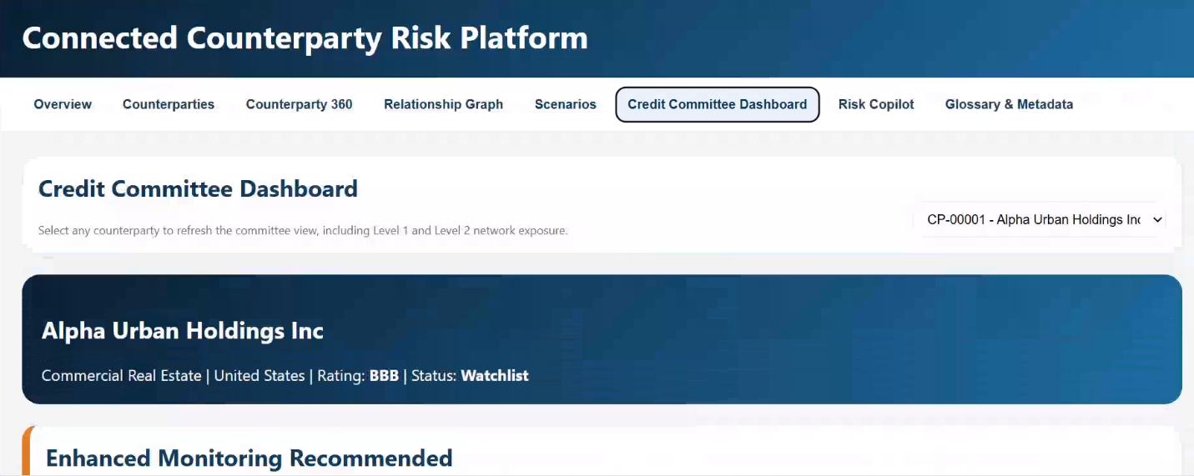
This dashboard section is designed to give the Credit Committee confidence that all risk exposure has been aggregated against the correct legal entity before making lending or credit decisions.
In large banks, the same company often appears in multiple systems:
- CRM system
- KYC system
- Credit system
- Trading platform
- External data providers
The company may be recorded slightly differently in each system.
Without proper resolution, the bank may mistakenly treat these as separate companies.
This creates two major risks:
- Underestimating exposure
- Overestimating exposure

Entity Confidence: High
This is one of the most important indicators.
It reflects how certain Senzing is that all matched records belong to the same entity.
Example Thresholds
Confidence Score | Rating
90-100 | High
75-89 | Medium
<75 | Low
A High confidence rating means:
- Name matches strongly
- Address matches
- Registration numbers match
- Ownership matches
- No significant conflicts found
Therefore the committee can trust the aggregation.

Potential Related Entities: 16
These are entities that are likely connected but not the same entity.
Examples:
- Subsidiaries
- Parent companies
- Sister companies
- Joint ventures
- SPVs
Example:
Alpha Urban Holdings
├── Alpha Urban Real Estate
├── Alpha Urban Finance
├── Alpha Infrastructure Ltd
├── Alpha Housing SPV
Total related entities found = 16
These can be included in group risk analysis.

Network Entities: 125
This is broader than related entities.
It represents the entire connected network discovered through:
- Ownership
- Directors
- Guarantees
- Trading links
- Shared addresses
- Shared beneficial owners
- Common counterparties
Example:
Alpha Urban Holdings
↓
16 Related Entities
↓
125 Network Entities
The larger the network, the more important network contagion analysis becomes.

Entity Resolution Summary (Powered by Senzing):
This section provides an independent validation that all exposures, facilities, guarantees, and connected-party relationships have been aggregated against the correct legal entity. Senzing resolves duplicate and fragmented records across internal and external data sources into a single trusted entity profile. High entity-confidence scores indicate that exposure calculations, relationship networks, and risk metrics shown throughout the platform are based on accurate counterparty identification, enabling the Credit Committee to make informed credit decisions with greater confidence.
________________
7. Risk Copilot
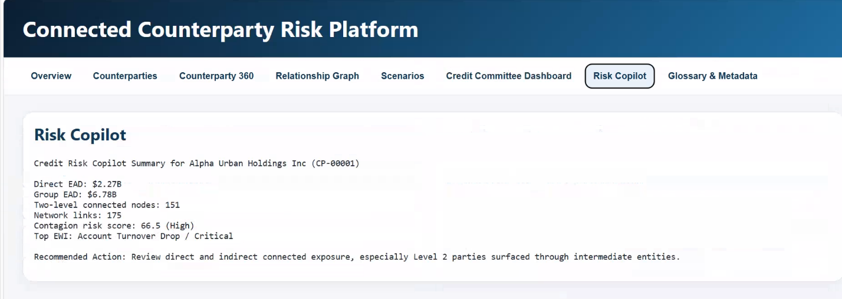
This could use Senzing's explanation capabilities.
For example, the user asks:
"Why is Alpha Urban Holdings connected to Alpha Healthcare?"
The backend could combine:
Senzing
Why are these records/entities related?
with:
Neo4j
What path connects them?
and:
Risk Engine
What exposure exists along that path?
Then Risk Copilot could answer:
Alpha Urban Holdings and Alpha Healthcare
are connected through a common ownership structure.
Path:
Alpha Urban Holdings
↓ OWNS 80%
Delta Real Estate
↓ OWNS 60%
Alpha Healthcare
Connected EAD: $XXX
Senzing has explicit why analysis functions for explaining entity-resolution outcomes, including why entities or records did or did not resolve.

